Inspect Evals: Researcher Support Program

Summary
- Inspect Evals is a publishing and maintenance platform for AI benchmarks.
- We’re launching a Research Support Program to help researchers publish their benchmarks to Inspect Evals.
- Successful applicants will gain access to 1:1 support from research engineers, $500 in compute credits, as well as ongoing maintenance commitments for any benchmarks contributed.

What is the Research Support Program?
The Research Support Program seeks to support 10 researchers currently working on exciting projects at the frontier of evaluations; providing tailored support and a compute budget to enable the highest quality and highest salience of the eventual benchmark.
The program will assist you to use the Inspect framework to develop your benchmark. At the end of the programme, the benchmark will be released on Inspect Evals at the same time as the paper publication, enabling the benchmark to be available to organizations and broader communities already using Inspect, such as UK AISI, Epoch AI, and METR. This helps us achieve our aims in providing benchmarks at the current frontier of the field to relevant users.
The program will guarantee:
- Dedicated development support, including compute credits, PR reviews and technical advice
- Weekly office hours for technical Q&A
- Monthly 1:1 meetings with our technical lead
All the support is completely optional, and you can tailor your program as needed. Nonetheless we expect the following to be broadly useful:
- Assistance throughout the entire design and implementation process: helping you refine designs and map them onto Inspect’s functionality
- Implementation support only: providing feedback on implementations throughout development
- Final PR review: for finished benchmarks which are developed in Inspect
Why join the program?
- Development support: our software engineers are experts in Inspect and benchmark development - they will be on-call to help you build your benchmark, providing advice on design patterns and reviewing code.
- Compute credits: We provide a $500 USD compute credit grant to assist with the development of your benchmark.
- Maximize reach and immediate use: Your evaluation will be instantly available to research organizations and projects that use Inspect. We will promote it to our user base as well as the broader community.
- Project support: you will have 1:1 support from our technical lead, Nelson Gardner-Challis, who has relevant experience across AI evaluation, software engineering and project management.
- QA & testing support: our tools and processes for QA & testing help ensure that your benchmark is free from bugs when it’s merged, and doesn’t break for downstream users
- Ongoing maintenance commitment: our full-time team of maintainers will address any bugs and feature requests, helping you stay focused on your next project
Timeline:
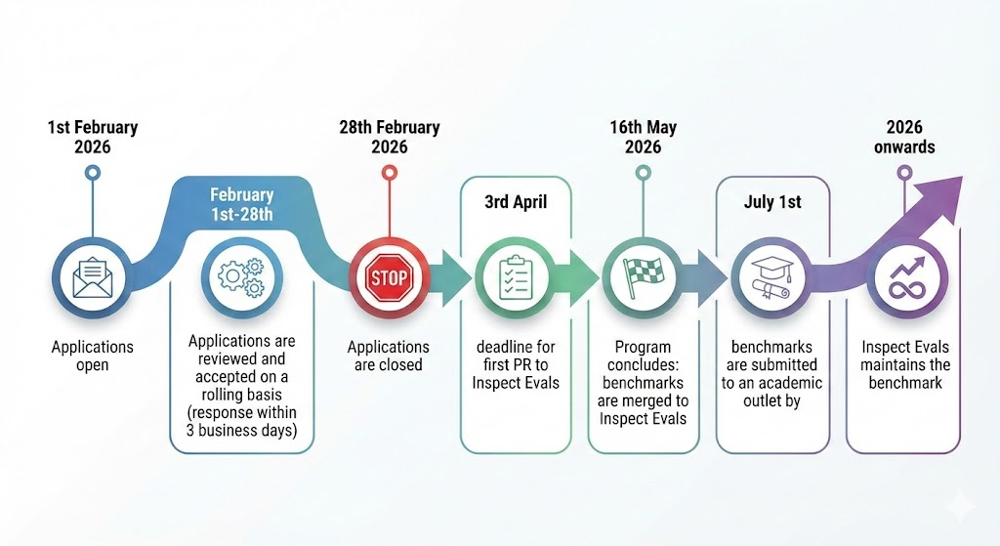

Who is eligible to join the program?
- Applicants must be must affiliated with an academic or nonprofit research group*
- Applicants must be either:
  - Planning to develop a benchmark
  - In the process of developing a benchmark
- The applicant must have a plan for submitting the benchmark to an academic outlet before July 1st 2026
*Industry groups (e.g. start-ups, technology companies) can submit benchmarks via our regular review process, but are not eligible for the additional support provided through the Research Support Program. Academic researchers that have short-term affiliations with industry organisations are still eligible.
Next Steps:

Complete the application form by 1st February AoE to be considered for the program.

FAQs / Considerations

What is Inspect?

Inspect AI is an open-source evaluation framework developed by JJ Allaire, the founder of R Studio. It was developed as a way for governments, industry and academia to have a common framework for developing and running agentic evaluations.

Who uses Inspect?

Inspect AI is the default framework for many large-scale, international AI evaluation exercises and organisations, including:

- The AI Evaluator Forum (METR, Transluce, RAND, SecureBio, and more).
- The Network for Advanced AI Measurement, Evaluation and Science (a consortium of government agencies including the UK AISI, the US CAISI, as well as agencies from, Singapore, Japan, Canada, US, France, Kenya).

Inspect is also used within frontier AI labs, start-ups, and academic labs, including the Alan Institute for AI, Anthropic and OpenAI. Google DeepMind published their self-reasoning benchmark to Inspect Evals:
- Ziyue Wang (Research Engineer): “Overall, I really appreciated the feedback from Alexander, and it provides a lot of useful feedback given this is the first time I contributed to the repo… and it is actively developed, and there's a chat channel, so I can ask questions and get some feedback, which is great.”

What is Inspect Evals?
Inspect Evals (IE) is an open-source evaluation publishing platform which allows researchers to share and use benchmarks implemented in Inspect. Users and contributors to IE include organisations such as NIST, Google DeepMind, the Vector Institute and Thinking Machines, Redwood Research. It is actively maintained by a team of 5 paid software engineers
IE is also highly integrated into the broader AI evaluation ecosystem, with Weights & Biases and Hugging Face both building integrations that help their users deploy Inspect Evals.
Do the Inspect Evals team need to be cited in the paper?
Co-authorship for Inspect Evals staff is NOT a requirement for being accepted into the program. For academic integrity purposes, it would be advisable to list Inspect Evals in the acknowledgements, especially if compute credits are used to produce results for the paper. For the purpose of building a community around Inspect Evals, we would also prefer that Inspect Evals is mentioned in the methodology section of the paper.
Who owns the code once it's in Inspect Evals?
Licensing and intellectual property remains in ownership of the original authors of the paper, and this will be cited within the specific benchmarks README file.
What if my benchmark is private?
For benchmarks which are private, or can only be published after a specific date, we can arrange confidentiality agreements and modify our processes to align with your infosecurity requirements.
If NDA’s are necessary for your benchmark to be included in the program, then these can be signed by relevant staff within the Inspect Evals team.
Will Inspect Evals have any influence over the design or implementation of my evaluation? What if I disagree with recommendations made by the maintainers?
In some cases, researchers might disagree with a recommendation put forward by a maintainer w.r.t the design or implementation of your benchmark.
- If this disagreement is on the basis of additional work required that they do not have capacity for, then we will elect to take on that additional work if we think it is justified.
- If the disagreement is based on divergent views about best practices, then we will look at ways to accommodate both approaches (e.g. through a parameter that allows users to select between two options).
  - If this option isn’t possible, we will default to using a written notice within the documentation for the evaluation, allowing us to accommodate implementation choices that we don’t officially endorse.
- The only hard requirements are security requirements for our organisational users. (We generally expect that researchers will acknowledge and align with these requirements).
You can read about our best practices in the following documents:
- BEST_PRACTICES.md - Guidelines developed by the Inspect Evals team
- EVALUATION_CHECKLIST.md - A checklist which can be used by contributors and reviewers when submitted new benchmarks
What if my plans change during the program? Can I still participate?
We accept benchmarks on the premise that they are targeted towards complex agentic behaviours, and will be finished within a certain time period.
In circumstances where there are significant deviations from the scope that is agreed upon during the application, we will review a researcher’s involvement in the program.
Any adjustments to the researcher’s involvement will ideally be agreed mutually by default; for example, we would offer a position in the next cohort if the researcher faces unexpected delays in the current iteration.
In some cases, we may conclude a researcher’s involvement if we have reason to believe that a participant has been dishonest or negligent, and their continued involvement is a reputational risk or unreasonable drain on resources.

